AV, Conference System & Video Display for each Venue - Samoa CHOGM 2024

Introduction
As the Commonwealth Heads of Government Meeting (CHOGM) approaches in October 2024, the selection of suitable venues plays a pivotal role in ensuring the success of this prestigious event. One crucial aspect that cannot be overlooked is the provision of AV, Conference System, and Screens to accommodate the diverse needs of attendees. In this paper, we delve into the importance of assessing these multimedia requirements based on anticipated attendance numbers. By carefully considering these factors in venue selection, organizers can guarantee a seamless and productive experience for all participants at the Samoa CHOGM 2024.

Main Plenary – Fale Fono Mulinuu
To ensure comfortable participation the following minimum specifications for AV services, conference system with two channels, heavy duty projectors, screens for 200 participants and 100 talking participants are listed below. The Fale Fono is well equipped with all the following below except for projectors and screens. These are listed at the following section.

1. Audio System:
- High-quality microphone system with at least 60 wireless/wired microphones for the talking participants.
- Advanced sound mixing equipment to ensure clear and balanced audio for all participants.
- Powerful speakers and amplifiers to cover the entire conference area.

2. Display and Video System:
- High-resolution projector(s) x 2 capable of displaying clear visuals on large screens for all 200 participants. Recommended (7,000 - 10,000 lumens)
- large projection screens x 2 strategically placed for optimal viewing angles.
- Video distribution system to ensure seamless transmission of visual content.
- 5 x TVs (minimum 75”)

3. Control System:
- Centralized control system to manage audio and video sources, volume levels, and other settings connecting to the current Fale Fono system.
- User-friendly interface for easy operation by AV technicians.

4. Storage & Networking and Connectivity:
- Robust network infrastructure to support high-bandwidth audio and video streaming.
- Compatibility with various devices for seamless integration and content sharing.
- Recordings for all sessions conducted in the conference room (External Storage)

5. Power Supply:
- Sufficient power outlets and backup power sources to ensure uninterrupted operation throughout the event.

6. Technical Support:
- On-site technical support team to handle any issues that may arise during the conference. Also, hard drives, multiplugs and enough extensions as well as snakes and other cabling cases to assist with aesthetics.

These specifications should provide a solid foundation for a successful AV services conference system for your event with 200 participants and 100 talking people.

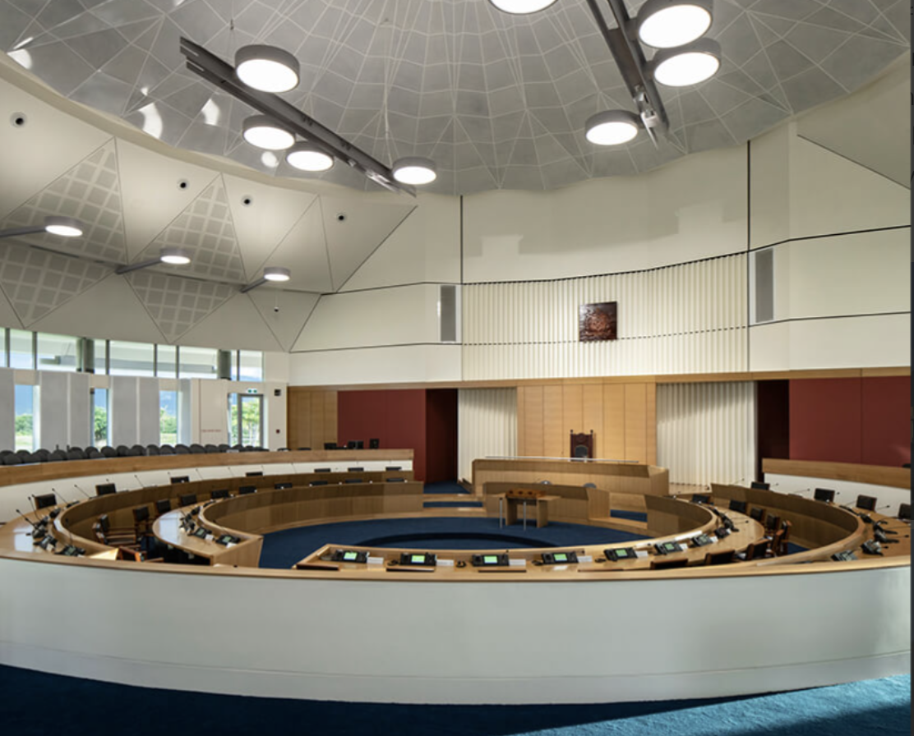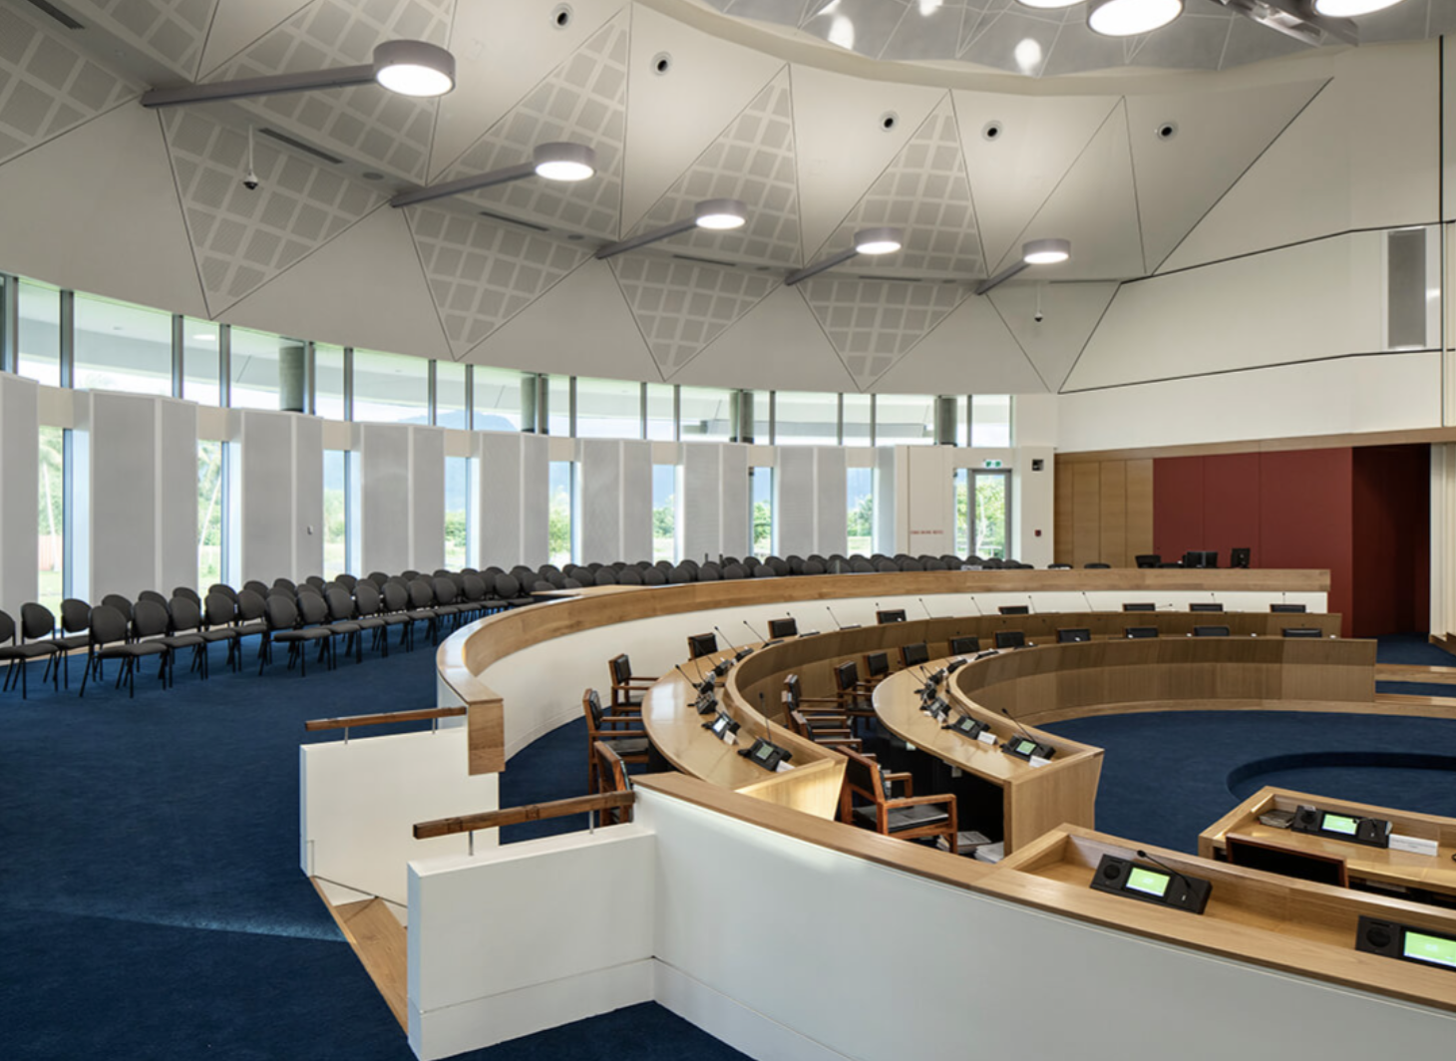

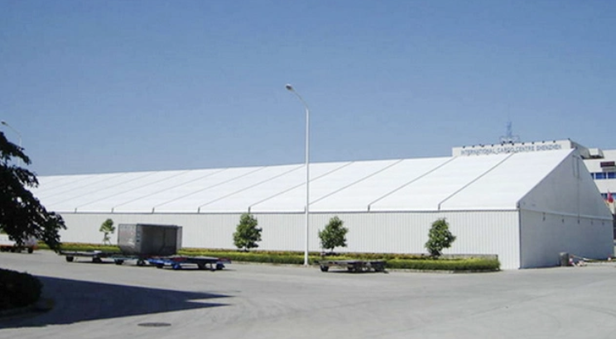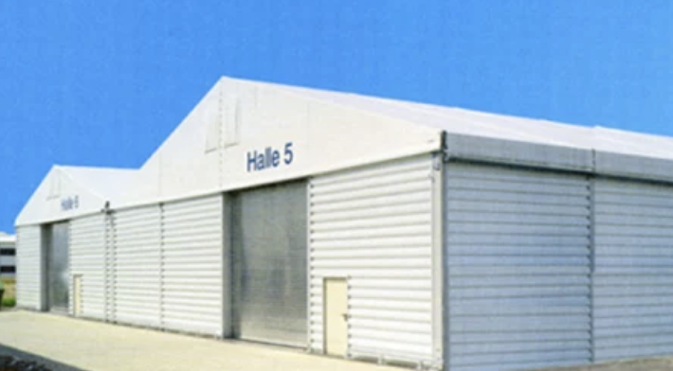

Photos of the venue. Samoa Fale Fono and Example of a Pavillion erected infront of the Malae Tiafau Field at Mulinuu.

Sheraton Conference Room
To ensure comfortable participation the following minimum specifications for AV services, conference system with two channels, heavy duty projectors, screens for 400 participants and 100 talking are listed below in each conference room. There are 2 conference rooms for these settings, hence why there are 2 setups proposed.

1. Audio System x 2:
- High-quality microphone system with at least 100 wireless/wired microphones for the talking participants.
- Advanced sound mixing equipment to ensure clear and balanced audio for all participants.
- Powerful speakers and amplifiers to cover the entire conference area.
- 20 earpieces per room

2. Video System x 2:
- High-resolution projector(s) x 4 capable of displaying clear visuals on large screens for all 400 participants in each room.
- Multiple large projection screens strategically placed for optimal viewing angles.
- Video distribution system to ensure seamless transmission of visual content.
-TV x 8 (minimum 65”)

3. Control System x 2:
- Centralized control system to manage audio and video sources, volume levels, and other settings.
- User-friendly interface for easy operation by AV technicians.

4. Storage & Networking and Connectivity: x 2:
- Robust network infrastructure to support high-bandwidth audio and video streaming.
- Compatibility with various devices for seamless integration and content sharing.
- Recordings for all sessions conducted in the conference room (External Storage)

5. Power Supply x 2:
- Sufficient power outlets and backup power sources to ensure uninterrupted operation throughout the event.

6. Technical Support x 2:
- On-site technical support team to handle any issues that may arise during the conference. Also, hard drives, multiplugs and enough extensions as well as snakes and other cabling cases to assist with aesthetics.

These specifications should provide a solid foundation for a successful AV services conference system for your event with 400 participants and 100 talking people in each of the Sheraton Conference Room.
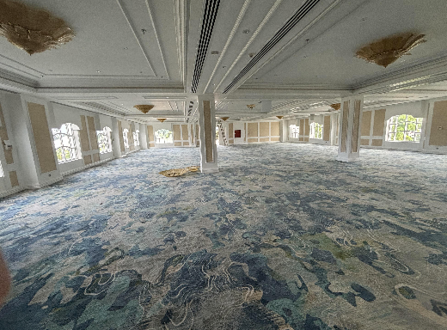
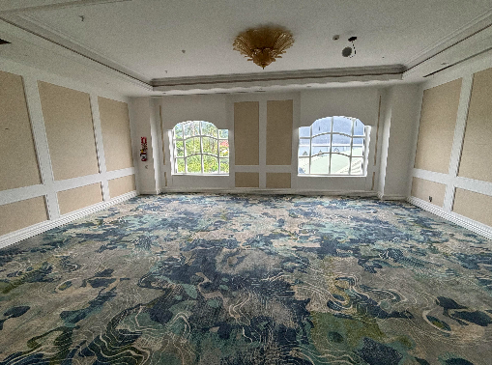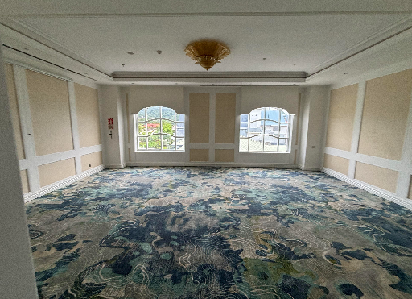

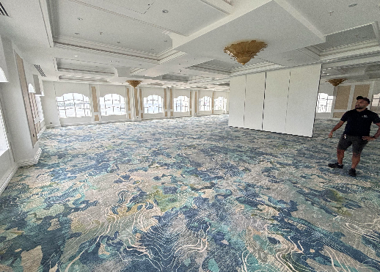

TATTE Conference Centre
To ensure comfortable participation the following minimum specifications for AV services, conference system with two channels, heavy duty projectors, screens for 300 participants and 100 talking are listed below in each conference room. There may be some screens that can be reused inside TATTE Conference Room. Supplier are asked to check and confirm before submitting final costings.

1. Audio System:
- High-quality microphone system with at least 100 wireless/wired microphones for the talking participants.
- Advanced sound mixing equipment to ensure clear and balanced audio for all participants.
- Powerful speakers and amplifiers to cover the entire conference area.

2. Video System:
- High-resolution projector(s) x 2 capable of displaying clear visuals on large screens for all 300 participants. Recommended (7,000 - 10,000 lumens)
- Multiple large projection screens strategically placed for optimal viewing angles.
- Video distribution system to ensure seamless transmission of visual content.
-TV x 4 (minimum 65”)

3. Control System:
- Centralized control system to manage audio and video sources, volume levels, and other settings.
- User-friendly interface for easy operation by AV technicians.

4. Storage, Networking and Connectivity:
- Robust network infrastructure to support high-bandwidth audio and video streaming.
- Compatibility with various devices for seamless integration and content sharing.
- Recordings for all sessions conducted in the conference room (External Storage)

5. Power Supply:
- Sufficient power outlets and backup power sources to ensure uninterrupted operation throughout the event.

6. Technical Support:
- On-site technical support team to handle any issues that may arise during the conference. Also, hard drives, multiplugs and enough extensions as well as snakes and other cabling cases to assist with aesthetics.

These specifications should provide a solid foundation for a successful AV services conference system for your event with 300 participants and 100 talking people in TATTE Conference Room.

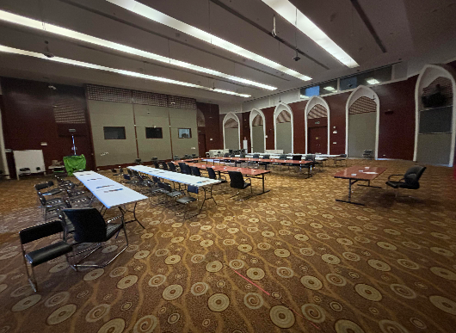

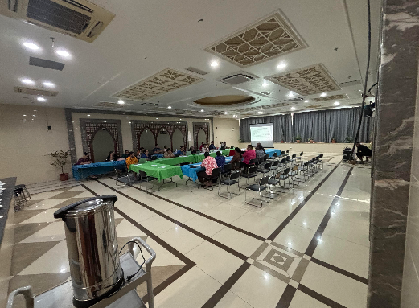

The setup will be conducted at the room upstairs while the room at the first floor is for Accreditation purpose.

Tanoa Tusitala Conference Room

To ensure comfortable participation the following minimum specifications for AV services, conference system with two channels, heavy duty projectors, screens for 200 participants and 100 talking are listed below in each conference room.

1. Audio System:
- High-quality microphone system with at least 100 wireless/wired microphones for the talking participants.
- Advanced sound mixing equipment to ensure clear and balanced audio for all participants.
- Powerful speakers and amplifiers to cover the entire conference area.
- 20 earpieces

2. Video System:
- High-resolution projector(s) x 1 capable of displaying clear visuals on large screens for all 200 participants in the room.
- Large projection screen x 1 strategically placed for optimal viewing angles.
- Video distribution system to ensure seamless transmission of visual content.
- 2 x TV (minimum 65”)

3. Control System:
- Centralized control system to manage audio and video sources, volume levels, and other settings.
- User-friendly interface for easy operation by AV technicians.

4. Storage, Networking and Connectivity:
- Robust network infrastructure to support high-bandwidth audio and video streaming.
- Compatibility with various devices for seamless integration and content sharing.
- Recordings for all sessions conducted in the conference room (External Storage)

5. Power Supply:
- Sufficient power outlets and backup power sources to ensure uninterrupted operation throughout the event.

6. Technical Support:
- On-site technical support team to handle any issues that may arise during the conference. Also, hard drives, multiplugs and enough extensions as well as snakes and other cabling cases to assist with aesthetics.

These specifications should provide a solid foundation for a successful AV services conference system for your event with 200 participants and 100 talking people in TATTE Conference Room.

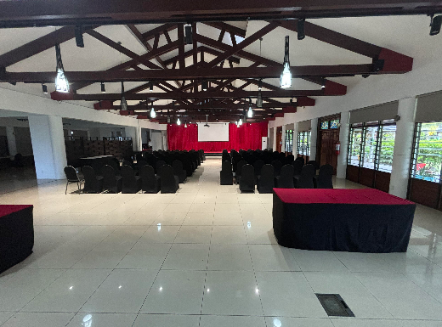
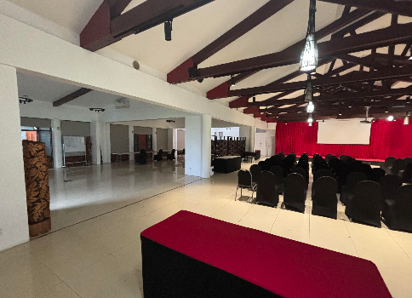

The following photos were taken inside the Tanoa Tusitala Hotel Conference Room.

EFKS Youth Conference Centre
To ensure comfortable participation the following minimum specifications for AV services, conference system with two channels, heavy duty projectors, screens for 400 participants and 100 talking are listed below in each conference room.

1. Audio System:
- High-quality microphone system with at least 100 wireless/wired microphones for the talking participants.
- Advanced sound mixing equipment to ensure clear and balanced audio for all participants.
- Powerful speakers and amplifiers to cover the entire conference area.

2. Video System:
-High-resolution projector(s) x 2 capable of displaying clear visuals on large screens for all 400 participants. Recommended (7,000 - 10,000 lumens) or LED Screen
- Large projection screens x 2 strategically placed for optimal viewing angles.
- Video distribution system to ensure seamless transmission of visual content.
- 4 x TV (minimum 65”)

3. Control System:
- Centralized control system to manage audio and video sources, volume levels, and other settings.
- User-friendly interface for easy operation by AV technicians.

4. Storage, Networking and Connectivity:
- Robust network infrastructure to support high-bandwidth audio and video streaming.
- Compatibility with various devices for seamless integration and content sharing.
- Recordings for all sessions conducted in the conference room (External Storage)

5. Power Supply:
- Sufficient power outlets and backup power sources to ensure uninterrupted operation throughout the event.

6. Technical Support:
- On-site technical support team to handle any issues that may arise during the conference. Also, hard drives, multiplugs and enough extensions as well as snakes and other cabling cases to assist with aesthetics.

These specifications should provide a solid foundation for a successful AV services conference system for your event with 400 participants and 100 talking people in EFKS Youth Conference Room.

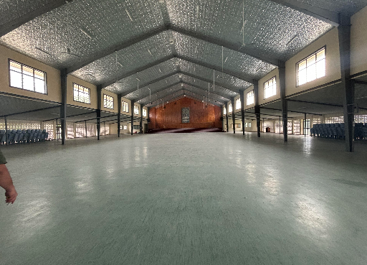

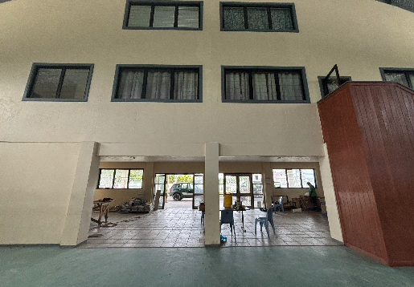

Side Events

Portable Mini Audio Systems (Bluetooth capabilities, battery 3-5 hours) x 20
Mics x 40
Projectors x 5

Venue | Location | Number of Participants (ppl)
Main Plenary – Parliament Building Grounds | Mulinuu | 200
Youth Forum | EFKS Hall, Sogi | 400
Peoples Forum | Tanoa, Sogi | 170
Women Forum | TATTE, Sogi | 200-300
Business Forum | Sheraton Hotel, Vaisigano | 400
Retreat | Sheraton Hotel, Mulifanua | 200
Opening Ceremony | Tuanaimato Hall, Tuanaimato Complex | 1000

